
October 2008 Volume II, No. 4
Among Friends

are volunteering for the library to purchase stuff to make your visits more pleasant and workable. We need your commitment.  Our sales have been very profitable thanks to Pat, Shirley and Margie. If you have the time please volunteer to assist them. Even if you can’t help with the sales perhaps you can help to sort books. Our book room is always packed with new donations and even one hour of sorting would be helpful! Books are sorted into categories many times during the week; stop in for more information whenever the door to our workroom is open. You can also e-mail the members of the team at margie@ pittsburghused books.com.  Our big October Book sale is coming up on the 23rd to the 27th. We will again have the sheet music from the forties and hope that you and your friends will tell all who are interested that we have this for sale!  Copies of our newsletter “Among Friends” have been sent, along with a letter from Holly, to PCBL (Pennsylvania Citizens for Better Libraries) to apply for their 2008 “Friends Newsletter of the Year” award. We feel very strongly that our newsletter is the best in Pennsylvania! I will let you know the result of our application.  Check out Holly’s column on this page. She would like to have an advocacy group from the Friends. Please step up to her request..  Our secretary, Shirley Streff, is resigning as she is moving out of town. We are very sad to lose her as secretary, book sorter and fantastic worker and hope that her move is a happy one. However, we do need a secretary to take minutes at our monthly meetings and are looking for a volunteer from the Friends membership to take over. Please volunteer!!  My email is joan.schwartzman@verizon.net; if you have any questions, suggestions or want to volunteer please let me know.  Thank you for all your help and cooperation. Joan  I have always imagined that Paradise will be a kind of library.  Jorge Luis Borges 1899-1986
  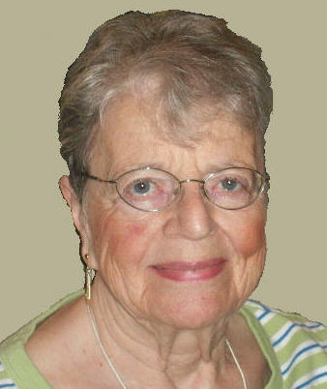 | PRESIDENT’S MESSAGE  by  Joan Schwartzman  Autumn is here and the weather is finally cooling off. Hopefully your work for the library is going to heat up as we continue to have sales so that we can provide the library with many items that they cannot otherwise afford. Please remember that we
  Advocacy Action Team
  If you believe strongly in the activities and services of the public library (and I know you do, otherwise you wouldn't be a member of the Friends!) consider adding your name to the Advocacy Action Team roster.
  As a member of the team you will put your support into action in the form of letters, e-mails, or phone calls as needed to advocate on behalf of the library.
  Our biggest need for advocacy usually occurs during the annual
  Commonwealth budget process so requests for help won't be frequent, but timing is often critical. It's imperative that we have an updated list of people who can respond to our call to action as need arises.
  If you're willing to become a team member or have questions, please e-mail or call me.
  Holly McCullough
  412-422-9650
  mcculloughh@carnegielibrary.org
  WELCOME, NEW MEMBERS
  Yonah
  Adriane Esposito
  Ronda Fingeret
  Theresa Graham
  Sharyn Kelson
  Anita Mallinger
  Olivia Robertson
  Marla Scheinman
  Leigh Anne Vrabel
  * * * * * * * * * * * * * * * * *
  Come to our monthly Friends Meetings
  on Saturday at 10:00 a.m.
  October 4
  November 1
  December 6
  EVERYONE IS WELCOME
Published by the Friends of the Squirrel Hill Library 5801 Forbes Avenue Pittsburgh, PA 15217
website: www.clpgh.org/locations/squirrelhill e-mail: Friends@pittsburghusedbooks.com
editing: Joan Schwartzman production: Margie Spenser, Marion Damick,
mailing list: Margie Spenser Leigh Anne Vrabel, Serena Spenser
I have always imagined that Paradise will be a kind of library
Jorge Luis Borges 1899-1986
October 2008 Among Friends Volume II, No. 4

  Art at the  Squirrel Hill Library  ----------------------------------------------------------  Coming up are:  October: Edward Yarov  Watercolors  November: Steve Smith  Mixed Media.  December:Nancy Harris  Oils on Wood.  Our schedule for artists is full through 2009! If you are interested in exhibiting after that, contact  Marion Damick,  412-521-3075. | were enriched by the Friends’ support. 1099 children, 178 teens and 299 adults participated in Summer Reading, and read over 6500 hours. This resulted in a contribution of $250.00 to Pittsburgh RIF (Reading Is Fundamental) as our “Reading Service Project” this summer. Thanks for making Summer Reading a  great success!  We have received many exciting new books over the past few months. Our nonfiction additions include many new animal, insect, body awareness and healthy living books for kids. You can find the new books at the entrance to the children’s room and among the picture books. Here is just a sampling of the many great new titles:  If I Ran for President by Catherine Stier  What’s Eating You? Parasites-The Inside Story by Nicola Davies  The Tooth Book: A Guide to Healthy Teeth and Gums by Edward Miller  Paleo Bugs: Survival of the Creepiest by Timothy Bradley  Super-Size Bugs by Andrew Davies  A Lion Grows Up by Anastasia Suen  Alive: The Living, Breathing Human Body Book by Anita Ganeri  National Geographic World Atlas for Young Explorers  The Great Big Schoolhouse by Richard Scarry  In other book news: the Pennsylvania Library Association recently announced this year’s winner of the Carolyn W. Field Award — Way Down Deep by Ruth White. This award to honor the best book published by a Pennsylvania author was established  Some fun programs to look forward to in the fall: Our normal storytime schedule will resume in October. Family Storytime on Mondays at 6:00 p.m. and Saturdays at 11:00 a.m.; Toddler Storytime on Tuesdays at 10:30 and 11:30 a.m.; Baby Lapsit on Thursdays at 10:30 and 11:30 a.m.  KinderPrep will also be starting again, on October 14, and will continue the second Tuesday of every month at 6:00 p.m. KinderPrep is a series of programs intended for children entering kindergarten in the fall of 2009. During the hour-long sessions, children's skills will be highlighted through stories, songs, and crafts that support the Pennsylvania Early Learning Standards. These involve different approaches to learning, creative arts, language and literacy concerns, logical and mathematical skills, personal and social skills, physical and health-related habits, science, social studies, and contacts. Call the children’s department at 412-422-9841 to register.
  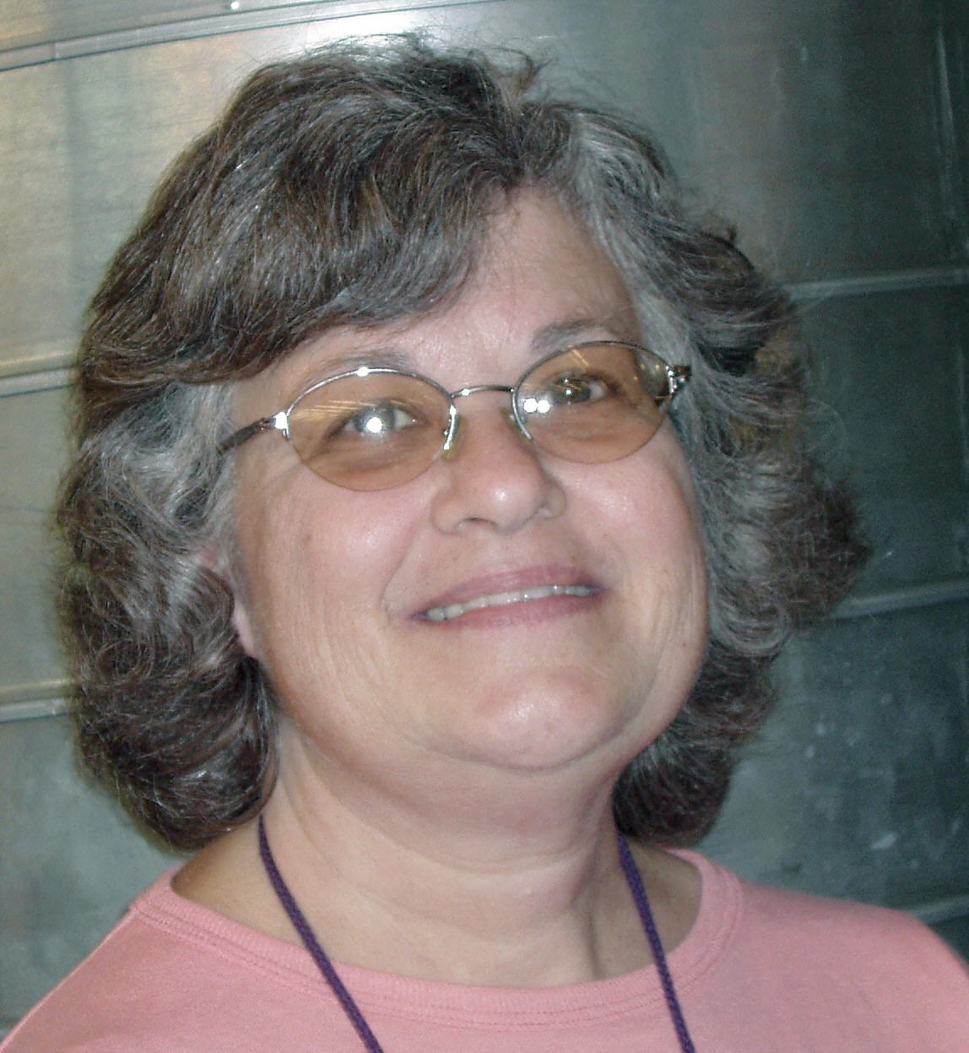  Susan Hughes  Sr. Children's Librarian | Children’s Department Happenings  by Susan Hughes and Erin Scioli  The Children’s Department would like to thank the Friends of the Squirrel Hill Library for their support of the 2008 Summer Reading Program. In addition to the fashionable “Catch the Reading Bug” and “Metamorphosis” t-shirts for staff and Friends, prizes, displays, and programs | 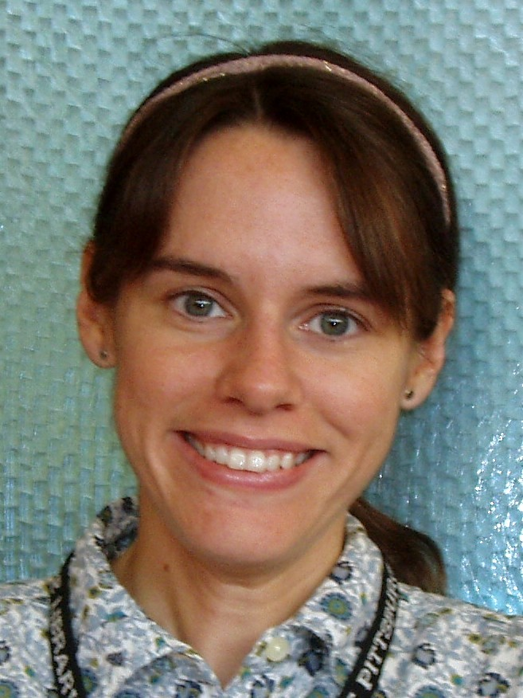  Erin Scioli  Children's Lib Assistant
  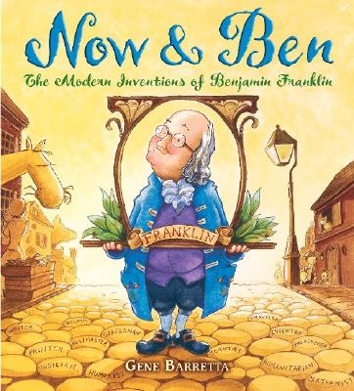 | in 1983 by the Youth Services Division of the Pennsylvania Library Association. A Distinguished Daughter of Pennsylvania, Carolyn Wicker Field retired in 1983 from the Free Library of Philadelphia where she served for 30 years as  Coordinator of Work with Children.  Now and Ben: The Modern Inventions of Benjamin Franklin by Gene Barretta was the 2007 winner, chosen in part by CLP-Squirrel Hill’s own Susan Hughes, who was part of the committee.
From Pittsburgh Magazine's
"Best In Pittsburgh" Issue:
September, 2008
“Best Reading Nook: When it's too rainy and cold to play outside, what's a kid to do? We know just the place to cure the rainy-day blues: The cozy window reading nooks at Carnegie Library's Squirrel Hill branch. There, kids can snuggle up with their parent and a favorite book in one of the brightly painted square niches. Located in the heart of the business district, the nooks also allow kids and their parents to overlook bustling Murray and Forbes avenues, which could give even Richard Scarry's Busytown a run for its money! 5801 Forbes
Ave., Squirrel Hill; 412/422-9650.
clpgh.org/locations/squirrelhill”
The primary use of conversation is to satisfy the impulse to talk.
George Santayana- 1863-1952
2

October 2008 Among Friends Volume II, No. 4

Film, Fiction, and Fun is a special series presented at the Carnegie Library of Pittsburgh, Squirrel Hill that  October 16th’s novel is Beloved , by Toni Morrison. This book tells the story of Sethe, a former slave living in Ohio whose past literally comes back to haunt her when the ghost of her deceased daughter arrives at her doorstep. Oprah Winfrey bought the film rights to this Pulitzer Prize-winning novel in 1987 and finally brought it to the screen in 1998 as both producer and star of the film. It received a single Oscar nomination, for costume design.  November -- no meeting  December 18th’s selection is Intruder in the Dust, by William Faulkner. This 1948 novel focuses on the trial of Lucas Beauchamp, a black farmer falsely accused of murdering a white man. Faulkner won the Nobel prize for literature in 1949, the same year that the film adaptation of this novel debuted. The film was directed by Clarence Brown, and starred David Brian and Juano Hernandez. It was shot entirely in Oxford, Mississippi, which is not only the setting for the story, but Faukner’s home town as well.  Forthcoming Film, Fiction, and Fun:  January: An American Tragedy by Theodore Dreiser  (movie A Place in the Sun with M. Clift and E. Taylor)  February: The Blue Angel by Heinrich Mann  (movie with Marlene Dietrich)  March: Othello by William Shakespeare  (movie with Laurence Olivier) | Point Breeze Friend Publishes  Book on Soviet Jewry
  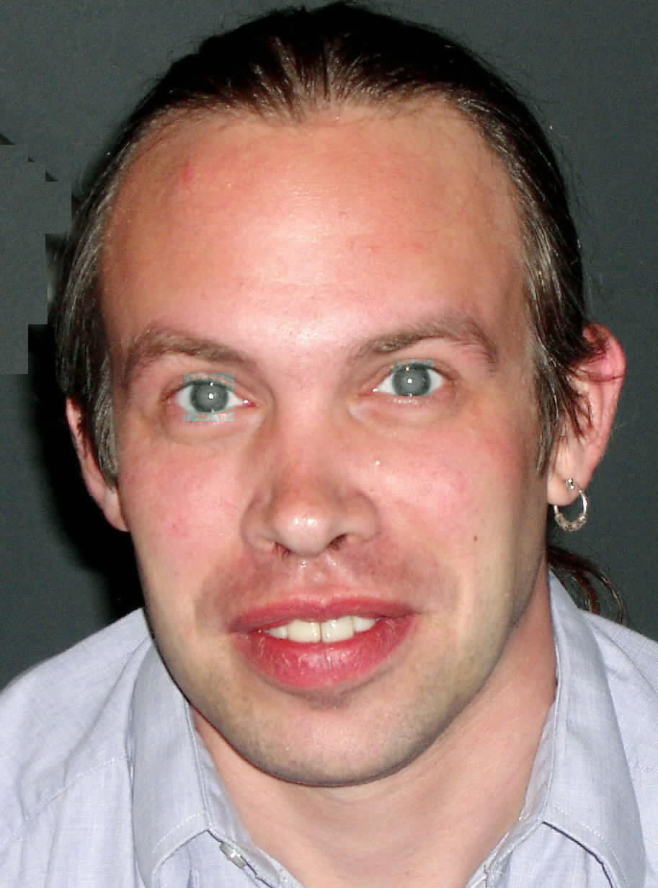  by Mark Russell  Librarian | Film,  Fiction, and  Fun – | 
  third Thursday of the month
  from 1 to 4 p.m.
  explores the relationship between films and the novels that inspired them. Attendees are encouraged to read a monthly fiction selection, then join CCAC’s Jeanne Bergad for a screening of the film and discussion to follow. | 
  Pittsburgh native Harriet Kruman has been active for many years and on many levels in the resettlement process of Soviet Jews. She was chair of the Women’s Plea for Soviet Jewry in 1982, and traveled in the USSR in |  | 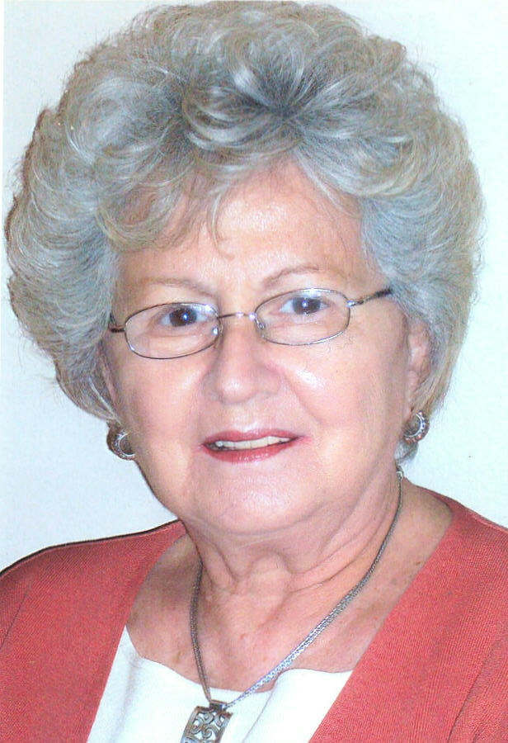
  1990 with the Pittsburgh Conference for
  Soviet Jewry. She and her husband Jules
  have served as mentors for Soviet families;
  she has tutored Soviet Jews in English and and helped them prepare for their citizenship
  tests. She conducts an ongoing class for for Russian-speaking women who meet to
  discuss current news, contemporary issues, etc.
  Kruman explains how she came to write
  The Huddled Masses:
  “I visited five cities in the former Soviet
  Union, meeting with the dwindling Jewish communities in each city. I felt that my experiences and background qualified me
  to write about Jewish life in the Soviet
  Union, as well as the resettlement process
  here. And because I have known so many
  in our community, it was easy for me to
  find people who were agreeable to being interviewed.”
  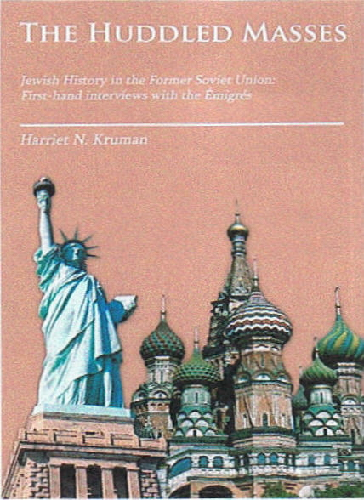 | The Huddled Masses, Author House, 2008  by Harriet Kruman  Against a backdrop of per-  secution and anti-Semitism, Soviet Jews suffered a tragic
  history as scapegoats, at the mercy of autocratic rulers. Kruman describes Jewish history in the former USSR; her experiences traveling in the Soviet Union; and her role
  as a volunteer in the resettlement of Soviet Jews, which led to personal interviews with 14 Pittsburgh immigrants caught up in the
  history of the USSR.
The best of my education has come from the public library…
my tuition fee is a bus fare and, once in a while, a fine on an overdue book.
You don’t need to know very much to start with,
if you know the way to the public library.
Lesley Conger 1950-2008

3
October 2008 Among Friends Volume II, No. 4

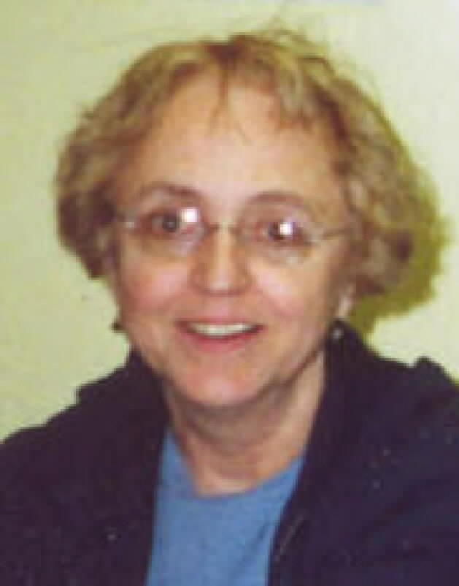 | MINI SALE NEWS  by Pat Bender, mini-sale chair  As this issue goes to press we have just closed September's Mini Sale of books on the subjects of religion, philosophy, and | Friends' Corner  A Dismal Prospect  At some near time, I’ve heard them say,  Our friends the books will go away –  The tomes we love are soon to be  The detritus of history;  They say that in the coming age  The screen will rule, and not the page,  And all our reading we will get  From Web and blog and Internet.  Oh, pray things will not come to this!  To hold a book and read is bliss,  To read in bed or ‘neath the trees –  A screen will never do for these!  Come, lovers of the book, en masse,  Let not this horror come to pass!  Stand fast and bold, and proudly say,  “They shall not take our books away!”  Esther Jacobson Tucker
  When asked for a caption for her picture, Esther replied "I'm a local writer, poet, and Friend of the Library since forever. I'm also a proud grandmother, but I don't know if that's really relevant..." (Ben, Hannah and Margo think it is.) | 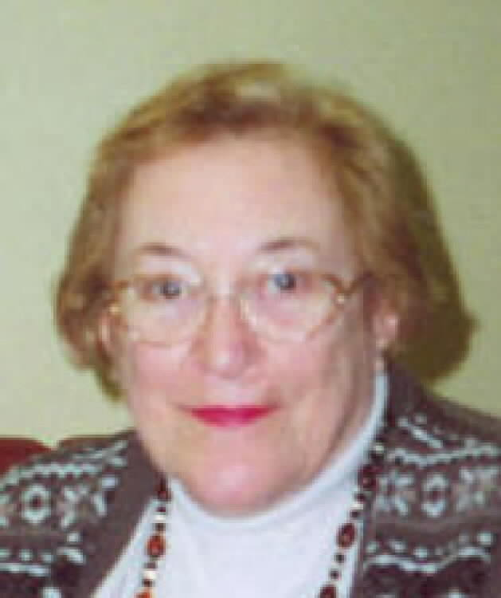
spirituality. There was an especially good selection of Judaica, thanks to a large donation from the Holocaust Center. They downsized their holdings by sharing their duplicates with us. We are very grateful. The FOL Boutique was also open and made about $100. We made more than $500 – a new mini sale record.

The FOL Boutique will also be open during the October sale, with special bookmarks, belts and jewelry items for Fall. There will also be an exciting selection of hand-made scarves for young people of all ages. At this sale we will also kick off the raffle of a hand-knitted mohair baby blanket. The winning ticket will be drawn at the end of the November sale, and tickets will be on sale near the Service Desk during the time between sales. The suggested donation is 50 cents a ticket, or three for a dollar.

The November sale is my favorite! We have been saving “like new” books since last November’s sale and we’re sure to have something beautiful and exciting for everyone to own or give. The Boutique will also have lots to offer.

Items Purchased Recently by the Friends For the Squirrel Hill Library

- Hundreds of children’s picture books to replace worn out popular titles.
- Teen Manga & Anime (very popular Japanese- inspired comics and movies) books and DVD’s.
- A staff announcements-and-marker board for the library staff lounge.
- Community news and bulletin board brochure and flier organizer.
- Health information literature holders for our consumer health section.
- A microphone and speaker system for our
large meeting room.

BOOKS, BOOKS, BOOKS, BOOKS, BOOKS, BOOKS, BOOKS, BOOKS, BOOKS, BOOKS,

When I first started working at the Friends book sales, there was only one each year, the Used Book Sale in October. Over the years, we've added three large sales and 5 or 6 mini sales, but the Fall sale still feels like The Biggie. It's when we clean out the whole workroom and start over; it feels like New Years Day and the first day of Spring put together.
 |  | 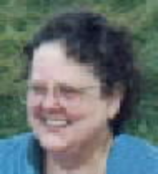  Margie Spenser  Book Sale Committee | We have a great collection of books ready to sell with more coming in every day. Come and load up; the prices will never be lower. Check out the flyer in this newsletter for details.  Now what we are working on is finding a home for what we don't sell. We'd like not to have a single book left to box up for the Free Box in the lobby. This year we are trying an idea that
has worked for libraries in other cities: we are inviting nonprofit groups to come to the last day of the sale (when we sell all you can fit into a brown grocery bag for $2). Their bags will be free.

The bag sale will not include classics or books for babies and young children ("picture books"), but there will be all kinds of fiction and nonfiction, including books for older children and teens.

Please let us know about any charity, school, religious group, etc.
you are familiar with that needs books. We will contact them
and arrange to send them our official "Free Bags" name tags.

To carry a book with you wherever you go is old advice and good advice. John Adams urged his son, John Quincy, to carry a volume of poetry. “You’ll never be alone,” he said, “with a poet in your pocket.”
David McCullough 1933-
4

October 2008 Among Friends Volume II, No. 4
To receive the Namm newsletter each month, email us at:  squirrelhill@  carnegielibrary.org   | Programs are scheduled for Wednesday  from 10:15 AM-11:00 AM except as noted  Inner Fitness: Holistic Stress Strategies  Learn to transform the stresses, conflicts and problems of modern day living  into a joyful, peaceful, fulfilling life.  Presented by Deborah Barr, Whole Health Resources  Wednesday, October 8, 2008 @ 10:15 AM.  But I Might Need It Someday!  Imagine being able to find things when you need them…not 3 weeks later.  If you’ve been miserable because clutter and chaos are ruling your life,  this program is for you! Increase your bottom line and morale and  decrease the stress and frustration of disorganization.  Presented by Patty Kreamer, President, Kreamer Connect  Wednesday, October 29 @ 1:00 PM.  *** special time  Choose The Right Website Designer For Your New Business  Learn to ask the questions that identify a vendor who is  capable of understanding your business objectives and strategic goals.  Define what it will take to deliver a website that fulfills your expectations.  Presented by Robert Faletti, co-founder, Blue Archer  Wednesday, November 12 @ 10:15 AM.  Learn About Key Databases Essential For A Winning Business Plan  Get marketing ideas from trade journal databases &  competitor listings in company directories.  Presented by Dorothy Kabakeris, Senior Librarian,  Carnegie Library of Pittsburgh – Squirrel Hill.  Wednesday, November 19 @ 10:15 AM.  Pennsylvania Sales Tax: Confusing And Amusing  Do you know what is taxable and what is not? What about mouthwash, pet food, thread or toilet paper? Find out which consumer products are taxable.  Protect your bottom line when standing in the checkout line.  Presented by Mary Bach, AARP Consumer Issues Task Force Chair  Wednesday, December 3, 2008 @ 1:00 PM  *** special time  Veterans & Spouses Of Veterans Looking To Start Your Own Business:  Find out about the financial incentives and advantages of  being a veteran in starting a business.  Presented by Donn Nemchick, Consultant and  2004 Veteran Business Advocate  Wednesday, December 17 @ 10:15 AM.
  NAMM BUSINESS CENTER PROGRAMS  October - December 2008  by Dorothy Kabakeris,  Namm Business Center Librarian | 
The Squirrel Hill
Adult Book Discussion Group
meets on the last Thursday
of the month.

All are welcome.

October 16 - 12 noon
(special day and time)
Sex, Lies, and Handwriting: a top expert reveals the secrets hidden in your handwriting.
by Michelle Dresbold with James Kwalwasser, 2006

Ms. Dresbold will talk to the book group and their friends; a book signing will follow.

November 20 - 1 p.m.
The Secret History of the War on Cancer
by Devra Davis, 2007

Dr. Davis will speak about her book to the general public in the Squirrel Hill Library, followed by a book signing.
See page 6 for details.

December – no meeting
It’s what we learn after we think we know it all that counts.
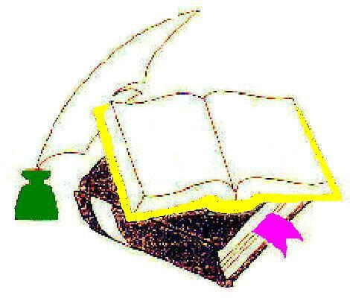 5
John Wooden 1910-

October 2008 Among Friends Volume II, No. 4 July 2008 Among Friends Volume II, No. 3

More Important People:  watch for more in the next issue | Special Program and Book Signing  Thursday, November 20, 2008 @ 1:00 PM.  Learn the gripping story of how corporate America may be more interested in treating cancer than in preventing it.  Hear Devra L. Davis, Ph.D., MPH, National Book Award Finalist and one of America's leading environmental health researchers, talk about her new must-read book The Secret History of the War on Cancer.  Find out how everyday products make us sick and what you can do to reduce your own exposure to carcinogens!  Dr. Davis directs the world’s first Center for Environmental Oncology at the University of Pittsburgh Cancer Institute. She has been interviewed on major national TV and radio networks and has lectured at the most prestigious medical and research institutions in the U.S.  Dr. Davis will have a book signing afterwards.
  
  Brandon Taper
  Sr. Clerk
  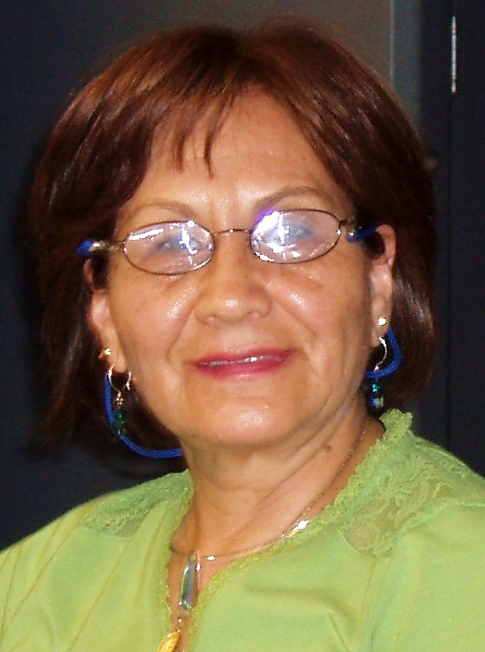
  Norma Bazan
  Clerk
  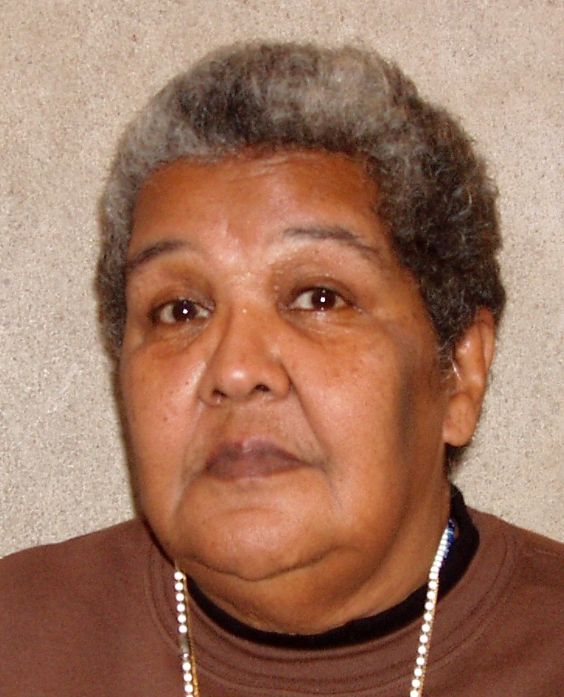
  Carmen Saunders
  Security Guard
  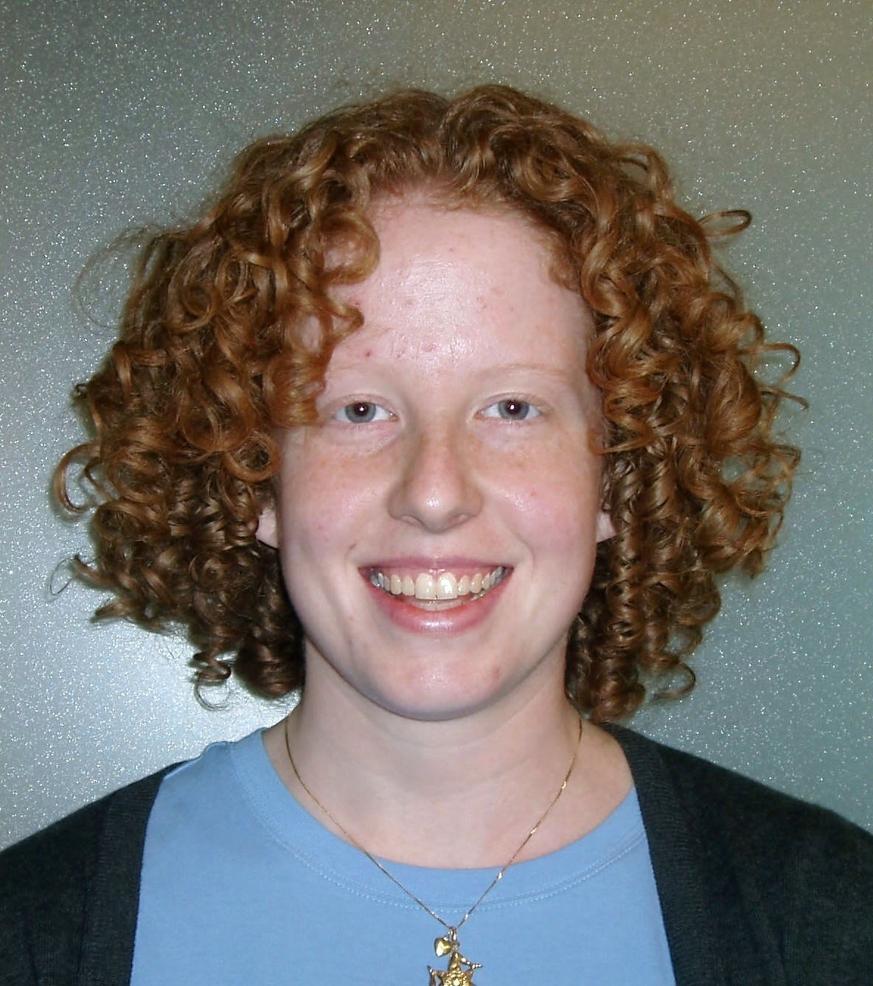
  Kate MacKrell
  Clerk
  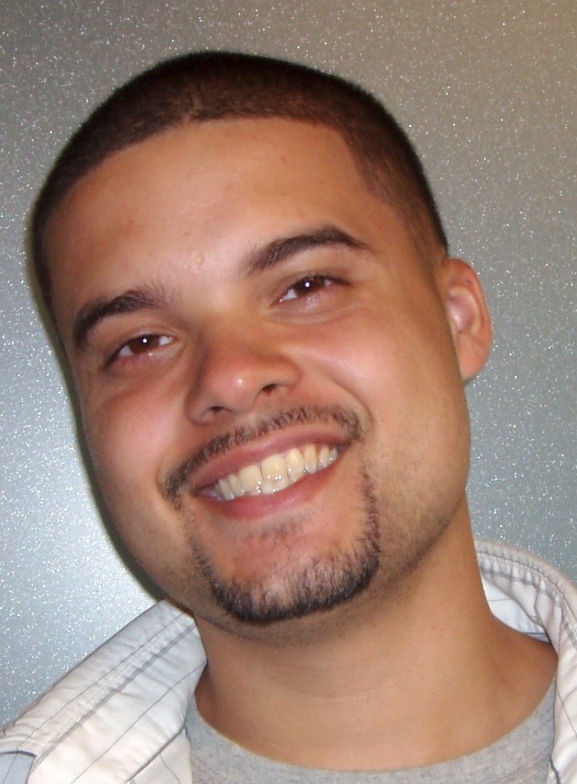
  Jose Diaz
  Clerk
New Programs on Healthy Aging Started  In September Carnegie Library – Squirrel Hill began offering two new programs for older adults.  For the Baby Boomers:  On September 15th we held a kickoff meeting for the "Take a Wise Walk" campaign, sponsored by the Allegheny County Library Association, PALS and AARP. It's not too late to join this 10 week program for all who would like to walk with a fun group from Squirrel Hill Library. If you don't want to walk with a group, you can walk on your own or with a friend. There's a meeting every Monday from 11 a.m. to noon to share experiences, plan walks, and learn more about aging and exercising. Check out the notice on | 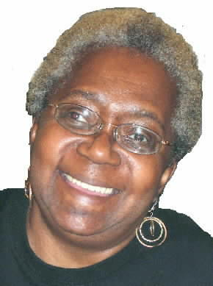  by Audrey Hines  Sr. Librarian
page 7 for details. Sign up at the "Ask a Librarian" desk or call 412-422-9650. There may even be some T-shirts left!

For Boomers, and for Generation X'ers who are starting to think they’re losing their minds:

Monday, Oct. 20, 11:30-12:30 Balancing for Your Health
Martine Marino, MPT, Center Manager, NovaCare Rehabilitation, Forbes/Shady Plaza

Tuesday, Oct. 28, 11AM-12PM Understanding Memory Loss
Lois Lutz, Program and Outreach Coordinator, Alzheimer’s Association, Greater PA Chapter
Many people worry about becoming more forgetful as they grow older. Our brains change as we age, just like the rest of our bodies. Most of us eventually notice some slowed thinking and problems remembering certain things. However, serious memory loss, confusion, and other major changes in the way our minds work are not a normal part of aging. This session will discuss the difference between mild forgetfulness and more serious memory problems as well as the medical causes of memory problems and how they can be treated. This session will be presented by the Alzheimer’s Association, Greater Pennsylvania Chapter. Please call to register @ 412-422-9650

Tuesday, Nov. 25, 11AM-12PM The Joy of Stress
Sandy Gilmore, RNMS, UPMC Living-At-Home and Staying-At-Home Programs
Discover comical and amusing ways to look at the stress in your life and how to handle it. Learn about the “Joy of Stress” with outreach nurse Sandy Gilmore, RNMS, with the UPMC Living-At-Home and Staying-At-Home Programs, in partnership with the University of Pittsburgh Institute on Aging. An entertaining 45 minute video will be followed by a short presentation and question and answer session. Handouts will be provided. Please call to register @ 412-422-9650.

Old wood best to burn! Old wine to drink! Old friends to trust! Old authors to read!
Archbishop Alonso de Aragon 1470-1520
6

October 2008 Among Friends Volume II, No. 4

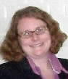  Holly McCullough Director | Getting Healthy @ Your Library  You’ll find throughout this issue that health resources are a recurring theme. Our own health and the health of our friends, families, community and world is a pressing concern for everyone. The Carnegie Library of Pittsburgh understands this and has dedicated many of our resources, services, and programs  to addressing those concerns and needs.  Be sure to check out the variety of special and ongoing free resources we have available.

Programs – Walking, Stress, Healthy Aging. See the details of just some of these upcoming programs in this newsletter, stop in for a monthly calendar of events, or check out our website at www.carnegielibrary.org.

Yoga classes – Tuesdays at 5:30 pm and Saturdays at 10:00 am.

Blood Pressure check – With a visiting nurse from UPMC’s Living at Home program, 2nd Tuesday of every month, 11:00 am.

Consumer Health Collection – Hundreds of titles available covering specific diagnoses and overall health and wellness issues.

Consumer Health Information Specialist – Librarian Mark Russell is trained and ready to help you access the information you need.

Health Databases - Free access to authoritative and up to the minute health information and news. Available through http://www.carnegielibrary.org/ with your library card.

Support for Library Funding

We recently put out a call for letters and e-mails of support for our status as a funded contractual asset of the Regional Asset District.

The Carnegie Library of Pittsburgh gets 71% of our funding from the 1% sales tax that funds the RAD. The RAD has convened a “Year 16” Committee to decide on any changes to the current funding structure. (2010 will be the 16th year of RAD’s existence.)

The Year 16 committee was asking for public input and we had a short turnaround time to alert our supporters. I got out the word to as many people as possible and we had a tremendous response from everyone we contacted.

Thanks to everyone who wrote or e-mailed the RAD. If you missed this opportunity to show your support for the library, please consider signing up with our Advocacy Action Team (see page 1) to get notices about future opportunities.

Friends Officers
Joan Schwartzman President
Marion Damick Vice President
Eleanor Hershberg Treasurer
Shirley Streff Secretary
write us at
friends@pittsburghusedbooks.com

Friends Used Book Sales

October 24-27 - The Biggie
with a special sale of vintage sheet music

November 13-16 – Holiday Shopping Mini Sale

December – no sale

January 17-18 – Mini Sale
to be announced

February 21-22 – Red, White &
Black History Mini Sale

for sales elsewhere, go to www.pittsburghusedbooks.com

Take a Wise Walk

Do you want to age healthfully?
Do you enjoy learning new things?
Are you an involved and
active 50+ adult?
Then join us for a ten-week
walking and health program.
Participants receive a complimentary pedometer,
walking guide, t-shirt and more!

Join us at a weekly meeting,
every Monday thru November 17
from 11:00 a.m. until noon,
to discover great resources, report your steps, and enjoy
a healthy-aging program and snack.
Sponsors: ACLA; AARP; Center for Healthy Aging; PALS
Registration is required.
Call 412-422-9650.
Lord! When you sell a man a book you don’t sell just twelve ounces of paper and ink and glue- you sell him a whole new life. Love and friendship and humour and ships at sea by night -- there’s all heaven and earth in a book, a real book. Christopher Morley,
Parnassus on Wheels, 1917

The Friends of the Library raise money to supplement the budget of our branch library

The Friends of the Squirrel Hill Library
5801 Forbes Ave. Pittsburgh, PA 15217
www.clpgh.org/locations/squirrelhill
friends@pittsburghusedbooks.com

I like to listen. I have learned
a great deal from listening carefully.
Most people never listen.
Ernest Hemingway
1899-1961
7

7

October 2008 Among Friends Volume II, No. 4
Thursday, Nov 13 10 a.m. to 4:30 p.m.  Friday, Nov 14 10 a.m. to 4:30 p.m.  Saturday, Nov 15 10 a.m. to 4:30 p.m.  Sunday, Nov 16 1 p.m. to 4:30 p.m.  DRAWING FOR THE WINNER OF THE HAND-KNITTED MOHAIR BABY BLANKET SUNDAY AT 4  DONATIONS WELCOME | Make checks payable to:  Friends of the Squirrel Hill Library  and mail to:  Margie Spenser  5900 Douglas St  Pittsburgh, PA 15217  Check one box:  New Member Renewal  Check one box:  $5.00 $10.00 DONOR (free)  $15.00 $25.00 Other _____  Name:___________________________________  ^{(Last)} (First) (Initial)  Address: _________________________________  City/State: __________________Zip: __________  Phone(s): ___________________Date: _________  E-mail address: ____________________________  Please check all activities you can help with:  Periodic Book Sales Sorting Used Books  Adopt-a-Shelf Program Gardening  Library Advocacy Newsletter/ Mailings  (lobbying, writing letters)  COMMENTS_________________________  _________________________________  _________________________________  _________________________________
  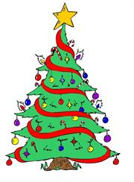 | HOLIDAY  SHOPPING  BOOK  SALE | 
  SPECIAL  BOOKS | LIKE-NEW BOOKS  FOR ADDED SPARKLE:  see Pat Bender's display of handcrafted  FOL book jewelry and other FOL jeweled  necessities. All proceeds go to the library.  CHILDREN'S BOOKS | COFFEE  TABLE  BOOKS
  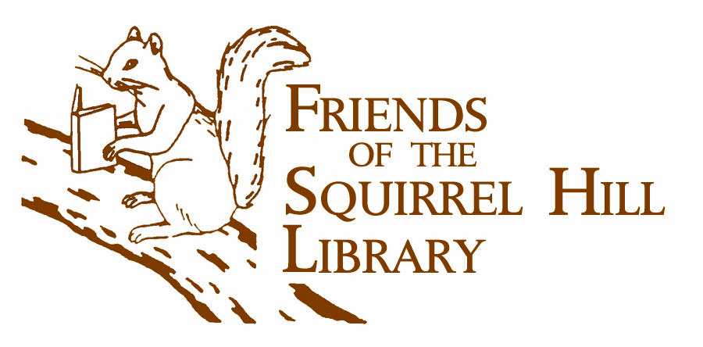 | Squirrel Hill Library  5800 Forbes Avenue  412-422-96508orbes 41212-422-9650 | 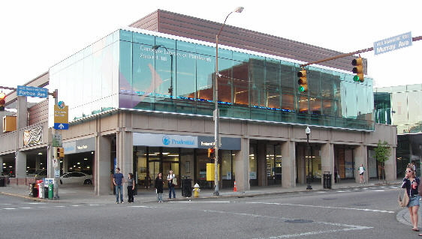
PLEASE CUT OUT THE POSTER AND PUT IT WHERE IT WILL BE SEEN BY MANY PEOPLE.
IF YOU WANT TO KEEP THIS ONE FOR YOUR REFRIGERATOR, YOU CAN PICK UP A FULL-SIZED ONE AT THE LIBRARY STARTING OCTOBER 1ST
Is your Friends Membership up to date? Please check your mailing label/membership card, below. If the date is before 10/08, you need to renew. If you bring this page to one of our Used Book Sales, you'll get a free book with your renewal. Or mail us the form above.
your donation is tax deductible as a charitable contribution

CARNEGIE LIBRARY OF PITTSBURGH  SQUIRREL HILL  5801 Forbes Avenue  Pittsburgh, PA 15217 |  | NON-PROFIT ORG.  U.S. POSTAGE  PAID  Pittsburgh, PA  PERMIT No. 307
Adult Services: 412-422-9650  Children's Services: 412-422-9841  Fax: 412-422-5811  www.carnegielibrary.org/clp/sq  membership card | ADDRESS SERVICE REQUESTED
  
  EXPIRES:  Month YYYY | NAME  ADDRESS  CITY, ST
8

